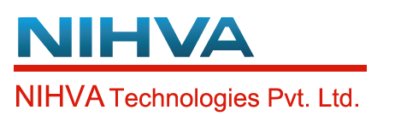 Date: - 13/01/2020
Quotation No: - SQT19-20.2329
Retractable Roof Proposal
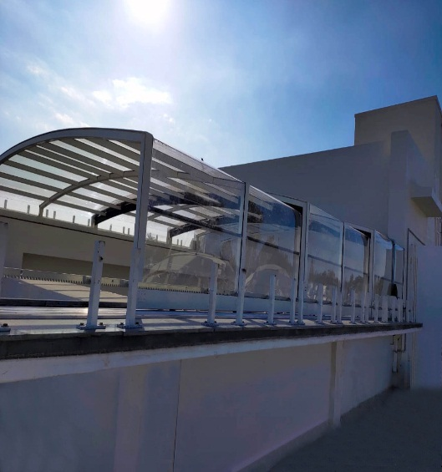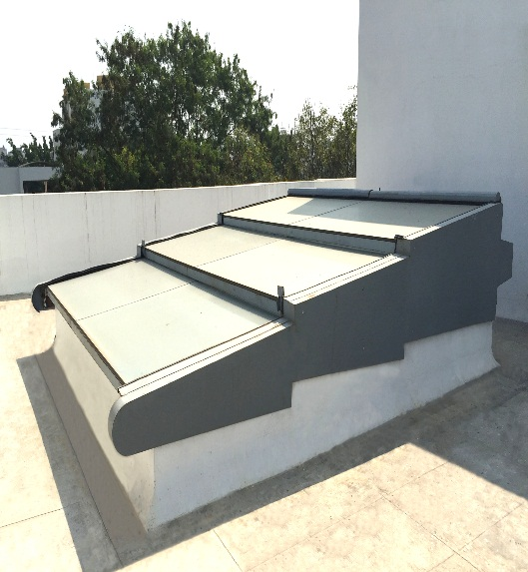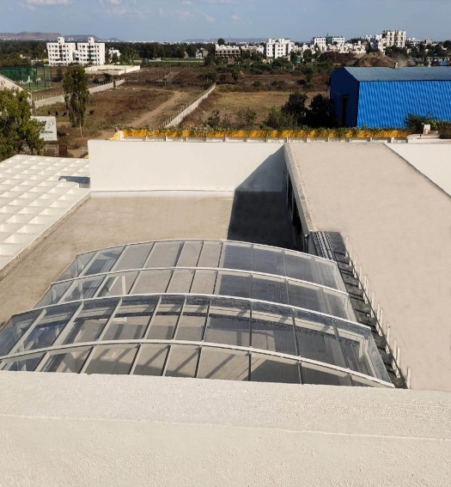

“NIHVA Technologies Pvt Ltd” are the prominent manufacturer, importer, exporter of a comprehensive assortment in Automation solution and Door Automation.
NIHVA specializes in providing customized solution for your different needs in Door Automation, Automation Solutions, Material Handling and Environment Solutions. We are headquartered in Pune, Maharashtra, India and have created a sustainable presence across India and in some parts of Middle East with the help of our business partners, sales personnel and service technicians.
A Retractable roof is a roof system designed to roll back the roof on tracks so that the interior of the facility is open to the outdoors.
Retractable roof is the new kind of innovation done for Bungalows, Hotels, Hospitals, Villas, Apartments, Commercial, where we can add more glory by allowing partial sunlight to enter in premises at day and sky view at night. We has in introduced many innovation in Smart Roofing or Retractable Roof.
Proposal and Quote
Sales Person: - Mr. Gaurav Jain
Client Name: - K. Raheja Group
Project Name: - Ramada Hotel- SKKY
Project Location: - Powai, Mumbai
Technical Specification-
Material and equipment for roofing system –

- Polycarbonate Israel make Compact/Embossed with UV protection on both sides. Sheets resist temperatures of - 100 to +120 °C

- Profile- Powder Coated AL Frame (As per RAL Colour)- The retractable roof is constructed with the combination of the 6060, 6061, 6063 grades Non corrosive Aluminium hollow extruded profiles. Aluminium extruded tracks Alloy- EN-AW-6060-T6 as per BSEN755.

- High grade Stainless steel SS304 fasteners are used to work against, the harsh environmental conditions.

- All the fabricated parts of the enclosure are manufactured with Stainless Steel material and powder coated as per as per the standards mentioned above.

- Guide- Anodized AL Guide

- EPDM- Ethylene Propylene Diene Monomer Synthetic Rubber Beadings and Gaskets-
The sealing of all the constituents are done by specially designed high-grade Ethylene Propylene Diene Monomer beadings and gaskets. Their excellent sealing properties ensure the enclosures 100% leak proof. Their excellent resistance to heat, oxidation, ozone and weather aging due to their stable, saturated polymer backbone structure. This ensures 100% water resistant enclosures

Automation

- Gear motors with synchronised operation with Rack and pinion arrangement. Operation through push button and remote control. Safety sensors/Switches for end limits.

- Limit Switch-Limit switch is a switch operated by the motion of a machine part or presence of an object. They are used for controlling machinery as part of a control system, as a safety interlock.
- Motor Specification -230V single phase, 600 watts, with electronic control card, 4 no’s. With complete wiring , Installation and commissioning

- Motors with Remote Control
- Italian Make BFT Brand
- Single Phase Bi-directional Motor
- Speed- 09-12m/min
- Rack and Pinion Arrangement -Z16/Molude4/Modul

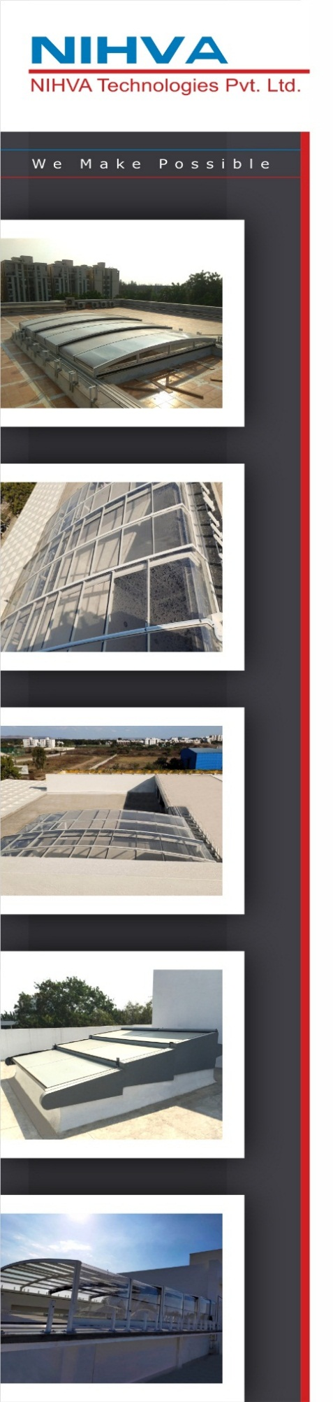

Supply + Installation Price | 1,94,00,000
P&F Charges 3% | 5,82,000
GST 18% | 35,96,760
Total with GST | 2,35,78,760
Commercial Specification: -
Option I – Double Roof
12000 mm (w) x 36000 mm (l) x 2500 mm (h) - 6 segments (2 no.)

Option II – Double Roof
25000 mm (w) x 36000 mm (l) x 4500 mm (h) - 6 segments
Supply + Installation Price | 3,30,00,000
P&F Charges 3% | 9,90,000
GST 18% | 61,18,200
Total with GST | 4,01,08,200

*Transportation as per actuals and Unloading in Client scope

Warranty
- 10 years for Polycarbonate Sheet.
- 3 years for Powder Coated Aluminium Profile.
- 1 year for motor.
- 1 Year from the date of supply.

General condition-
- Installation will start after receiving of site Readiness Photographs or written Email Communication
- We will mobilize the installation Team in 3-4 Working days, after receipt of site Readiness Confirmation
- For any reason if we need to stop our installation and demobilize Team without Completing the work, then extra cost will be applicable for remobilizing the team.

These items are not included in the offer
- Secured and fully Covered Store area to keep the material
- Scaffolding/Hydra/Carne/Forklift etc. - Required for installation at site
- Electrical Supply on the Single Phase/ three phase point at different places
- Any civil/masonry/ structural work required
- In case of any changes in layout as per site requirements after the shipment of material, the additional quantities and the wastage

Terms and Conditions
- Price - EX Works Pune
- Delivery – 4-5 months from date of receipt of Confirmed Purchase order, Advance Payment and Drawing approval.
- Payment – 80% Advance along with Confirmed Purchase order and Balance before dispatch.
- Validity – Validity of offer is 15 days from the date of quotation.

